Sprint One Report
Portfolio task 5
Unit code: EAT40006
Unit Name: Engineering Technology Project B
Submission date: 24/08/2025

Acknowledgment of Country
Each team member identifies the Traditional Owners of the land they lived on while completing this work.
- Senupama Damdini Deshapriya acknowledges the Wurundjeri Woi Wurrung people as the Traditional Owners of the land they lived on while completing this work in Melbourne, Victoria.
- Chrishelle Anthoneyz acknowledges the Wurundjeri Woi Wurrung people as the Traditional Owners of the land they lived on while completing this work in Melbourne, Victoria.
- Haritha Manuja Perera acknowledges the Wurundjeri Woi Wurrung people as the Traditional Owners of the land they lived on while completing this work in Melbourne, Victoria.
- Thenura Dulnath Kuruppuarachchi acknowledges the Wurundjeri Woi Wurrung people as the Traditional Owners of the land they lived on while completing this work in Melbourne, Victoria.

Contribution summary (This Sprint)

 | Contribution | Initiatives | Communication |  |  |  |  |  | Respect
Team Member | Finished tasks in time or on time with an acceptable quality | Self-assigned tasks and proactively found solutions to problems | Attended all team meetings | Attended all supervisor meetings |  | Attended all client meetings | Replied every time within an acceptable timeframe | Kept the team updated about the status | The student respected others and listened to different opinions
Thenura Kuruppuarachchi | Yes-rebuild the modifications in the pipeline and in the drainage systems | Yes- coordinated and troubleshoot modelling problems | Yes |  | Yes | Yes | Yes | Yes | Yes
Haritha Perera | Yes- completed the animations in the whole model | Yes- did the phase 3 and added the animation to it | Yes |  | Yes | Yes | Yes | Yes | Yes
Senupama Deshapriya | Yes- worked on phase 1 and also with the color coding of the compartments | Yes-did a research on pipeline systems for the model | Yes |  | Yes | Yes | Yes | Yes | Yes
Chrishelle Anthoneyz | Yes- remodelled the phase 1 and the base structure of the model. | Yes- added some hinges with moments around the axis | Yes |  | Yes | Yes | Yes | Yes | Yes

Contribution Details (This Sprint)
Haritha Perera
Haritha worked mostly on the animation side of the model. His first task was finalising paddles with the correct behaviour, which included paddle rotation, lid movement, allowing for counter-rotational behaviour, given that this was part of composting logic. Haritha also started some animations for airflow and condensation, so that arrows were ready for further refinement in future sprints. Haritha took care of modelling Phase 3 (the collection stage), and his animation work acted like a paralleling and an anchor to the structural changes he was making. This work made the model feel considerably more realistic and usable in a demo model.
Thenura Kuruppuarachchi
Thenura did a great job acting as Scrum Master, coordinating the teams and ensuring that sprint tasks were not delivering against reports/standards. He rebuilt structures components, not just by fixing the corrupted files, but added transparent walls, and ensured lids worked. Thenura added piping and condensate outlet systems, and checked that these components stayed within the lines of what the hardware team expected to redesign. He ensured there were no labelling discrepancies throughout the model. He did some research on water tank systems, and finalised the drainage logic to go with. Thenura's role extended to communications and integration, all components needed to fit together.
Chrishelle Anthoneyz
Chrishelle put the model's structure together piece by piece. She started by making sure all of the measurements were correct by being aware of what measurements were missing and ensuring the right dimensions in each of the individual chambers. Chrishelle rebuilt the base structure of Phase 1 of the model and ensured it was representative of what the client expected and modeled the Phase 1 parts and ensured the real hinges were modeled with the same axis of rotation, with no animation set until later. Chrishelle was also kept up to date with her Jeera tasks, as well as documentation, ensuring it aligned with what was recorded, and the model was in a state of evolution.
Senupama Deshapriya
Senupama took charge of researching the piping systems, ultimately deciding on the best configuration for condensation and airflow. She modeled the pipe system according to the needs of the chamber during one of the collaboration sessions, and can be seen integrated with the over composter design. Senupama contributed to the modeling of Phase 2 by pulling all of the parts together to a complete model. She also provided insights for colors and transparency's, for each composting stages red, green, and dark colors to distinguish them visually. We thoroughly appreciate any groundwork developed towards testing from Senupama's mind for the documentation and setup notes.
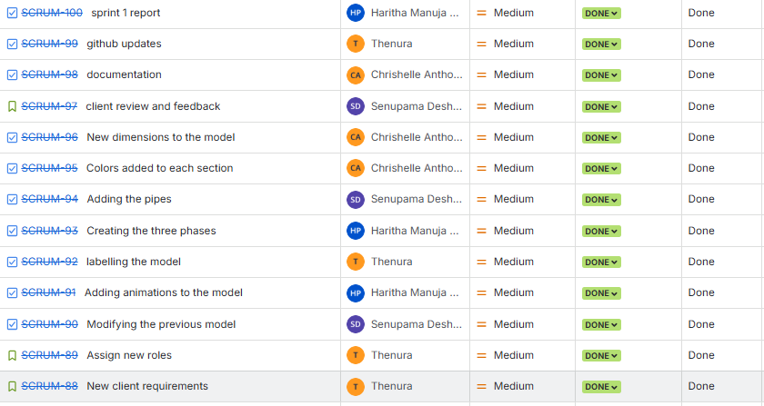

Figure workload equally distributed among the team members

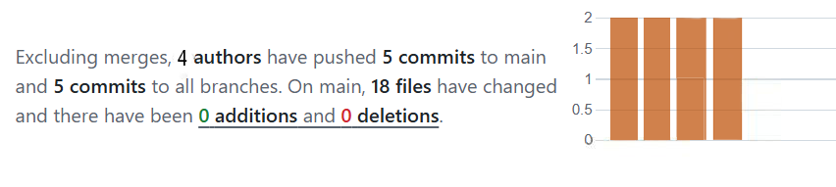
Figure GitHub Commits

sprint plan
Sprint Duration: Week 1 – Week 3 (Semester 2, 2025)
Sprint Goal:
The main objective of Sprint 1 was to finalise the updated 3D composter model with correct dimensions, integrate pipeline and chamber structures, begin animations (gas/moisture flow, paddle mixing, lid movement), and prepare the model for testing future app integration. The sprint also aimed to establish the testing framework (unit, module, system, usability) and update documentation practices (weekly logs, Jira, GitHub).
Sprint Backlog & Deliverables:
- Update chamber structures with correct measurements.
- Research, design, and model the pipeline system for condensation and gas/moisture release.
- Integrate chambers into a single unit with improved flow dynamics.
- Add transparent chamber walls, colour coding (top – red, middle – green, bottom – dark).
- Begin animations:
  - Gas (red arrows) & moisture (blue arrows) flow.
  - Condensate container filling.
  - Paddle rotation and mixing.
  - Lid opening/closing.
- Phase 2 modelling (with all components assembled).
- Initiate unit testing setup for app integration.
- Upload meeting minutes, weekly logs, and regular GitHub commits.
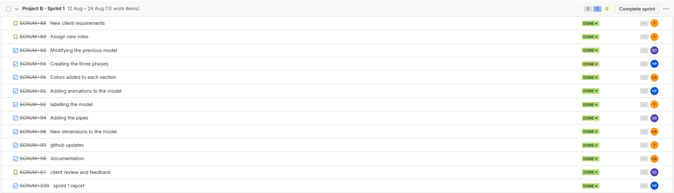
Figure 1.1 Backlog
Roles (Sprint 1):
- Scrum Master: Thenura Kuruppuarachchi – coordination, assembly fixes, piping and condensate system.
- Senupama Deshapriya: Research on pipeline systems, modelling pipeline, colour coding, Phase 2 component assembly, testing setup, documentation.
- Haritha Perera: Animation of paddle mixing, lid movement, airflow.
- Chrishelle Anthoneyz: Phase 1 modifications and the base structure of the model, Jira updates, documentation, verification of task alignment with client expectations.
Planned Artifacts for Submission:
- Updated 3D model (SolidWorks).
- Draft animations (gas, moisture, paddle, lid).
- Phase 1, 2 and 3 assembled models.
- Unit testing setup notes.
- Sprint 1 meeting minutes and logs.

Risk management plan

Risk | Impact | Likelihood | Mitigation Strategy
Team member leaves mid-project | Increased workload and reduced productivity | Medium | Redistribute tasks, consult supervisor for reallocation, adjust sprint scope
Misunderstanding of project scope (client requests mid-sprint) | Time wasted on rework or irrelevant features | High | Maintain regular client/supervisor communication, document changes in Jira immediately
Communication breakdown within team | Poor coordination, delays in deliverables | Low | Weekly meetings, real-time updates via Discord/WhatsApp, assign backup roles
Client unavailability or slow feedback | Delayed approvals, unclear priorities | Medium | Schedule weekly check-ins, document expectations clearly, escalate if needed
Dependencies on hardware team (sensor/motor alignment) | Misalignment between physical and virtual composter | Medium | Schedule sync meetings with hardware team, mark placements in 3D model early
SolidWorks file corruption/version mismatch | Loss of work, delays in modelling | Medium | Maintain GitHub/OneDrive backups, use version control and checkpoints
Difficulty animating/exporting 3D model | Failure to embed model in mobile app | High | Start with simplified exports, test in early stages, consult supervisor if issues persist
Over-complexity in 3D model design | App performance slowdown, confusion for users | Medium | Balance detail vs usability, prepare lightweight versions for mobile testing
App performance issues on devices | Inconsistent experience, crashes | Medium | Test across multiple devices, optimise model/animations, implement error handling
Data connectivity issues with sensors | Loss of real-time data or inaccurate readings | Medium | Validate sensor input ranges, set default fallback values, log errors visibly
User confusion due to poor UI design | Users may not understand app features/data | Medium | Conduct quick usability tests, improve layout, use colour coding and tooltips
Inadequate time for animation refinement | Deliverable lacks clarity/interactivity | Medium | Follow staged animation plan (basic → advanced), review progress weekly
Pipeline system complexity | Drainage/airflow misalignment, redesign delays | Medium | Test pipeline as a subsystem before integrating, adjust dimensions iteratively
Compost visual realism | Client dissatisfaction if textures look artificial | Medium | Introduce organic textures (banana peels, scraps, shading) progressively
Mobile export optimisation | Export too heavy for mobile integration | High | Weekly lightweight exports (GLB), test performance iteratively in Unity app
Integration of multiple animations (paddles, lid, arrows) | Animations may conflict or fail to sync | Medium | Test animations individually before merging; maintain separate versions
Testing delays due to Expo deadline | Risk of incomplete testing before Capstone Expo (Nov 28) | Medium | Begin unit testing early, allocate time for system/usability testing
Incompatibility between Unity app and SolidWorks outputs | Model may fail to run smoothly in Unity | Medium | Trial different export formats, consult documentation, optimise geometry
Unrealistic client expectations (scope creep) | Extra features requested beyond sprint plan | Medium | Clarify sprint goals in meetings, log all requests, negotiate timeline impact
Hardware–software mismatch | Sensors/motors may not fit where model places them | High | Continuous sync with hardware team, test with mock sensor/motor placements
Timezone/availability issues (weekly meetings with client) | Misalignment in feedback loops | Low | Share meeting summaries immediately, request clarifications asynchronously
Burnout from heavy parallel workload | Drop in quality or missed deadlines | Medium | Monitor workload via Jira, rotate responsibilities, encourage balance
Export licensing/software issues (SolidWorks/Unity) | Work delays due to software restrictions | Low | Ensure team has correct licenses, test exports early, request support if needed

Sprint PRogress
Sprint 1 achieved significant technical and design progress aligned with the sprint backlog.
Progress Highlights:
- Pipeline System:
  - Senupama conducted research into pipeline and drainage designs.
  - The pipeline was modelled and integrated into the composter with condensate outlets.
- 3D Model Updates:
  - Thenura rebuilt chamber structures after corruption issues.
  - Chamber alignment corrected, lids refined for sealing, transparent walls added for visibility.
  - Colour coding applied (top red, middle green, bottom darker shade).
- Phase 2 Modelling:
  - Senupama contributed by assembling all essential components into Phase 2 structure.
  - Integration ensured pipeline and chamber systems worked cohesively.
- Animations:
  - Haritha developed draft paddle mixing and lid movement animations.
  - Flow animations (gas, moisture, condensate) were initiated.
- Documentation & Tools:
  - Chrishelle oversaw Jira updates and ensured tasks matched client expectations.
  - Weekly logs, meeting minutes, and GitHub commits were maintained.
Testing:
- Unit testing protocols were drafted, with focus on app integration later.
- No system or usability testing at this stage, but groundwork prepared.

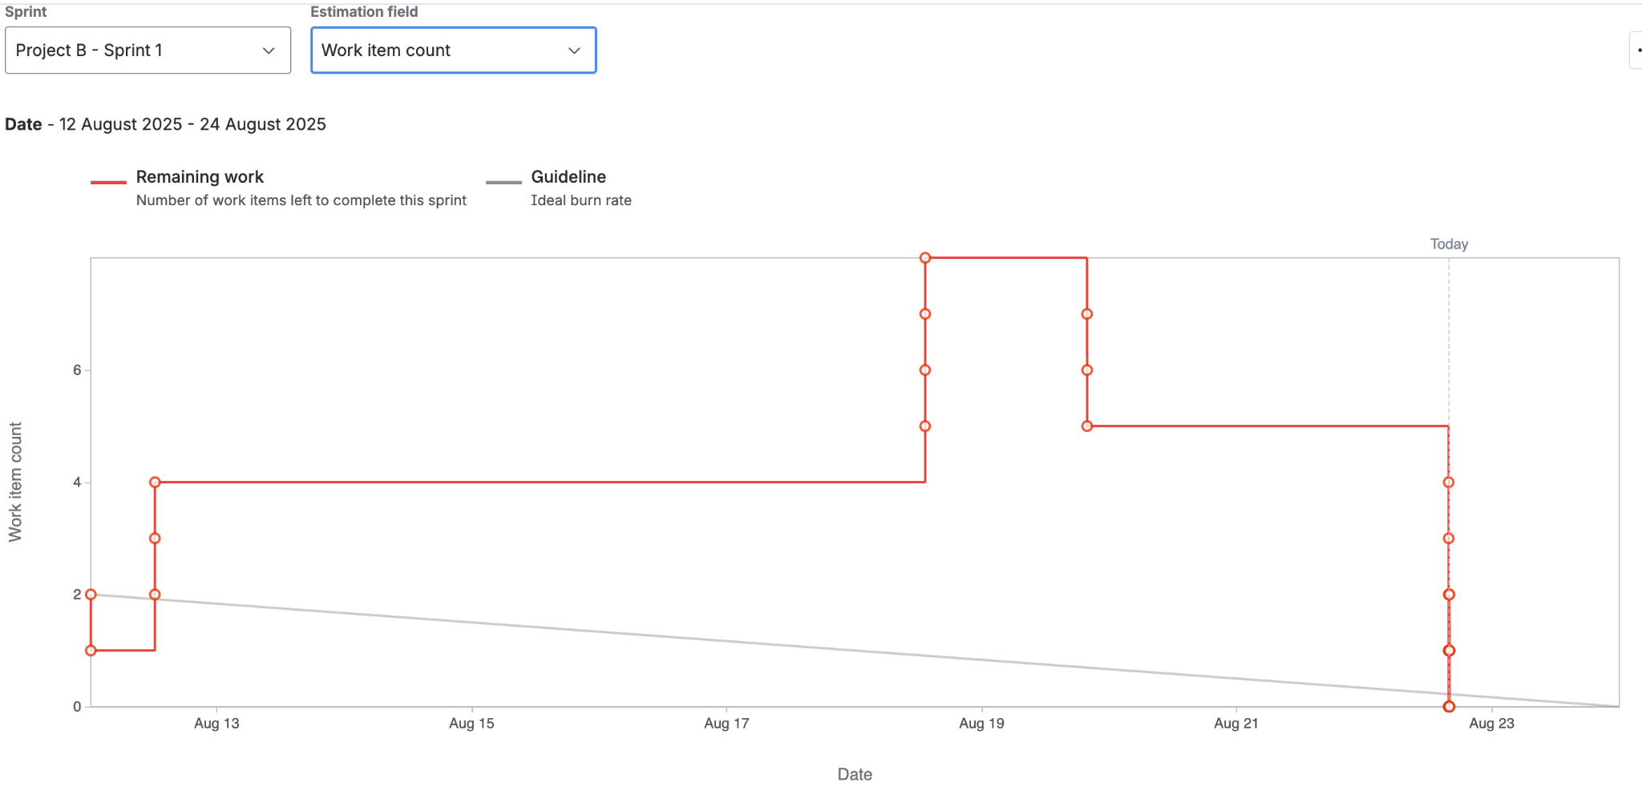
Figure 1.2
The spikes in the burndown chart reflect new requirements introduced mid-sprint based on client feedback.
The clustered task completion reflects the parallel workflow of the team, where different members worked on separate components (pipelines, chambers, animations, documentation) and finalised them simultaneously once integrated.
Although the burndown looks uneven, it still reflects healthy progress since the sprint backlog was adapted responsively, and all core goals were achieved by the end of the sprint.

sprint review (Critical review of the product)
Sprint 4 Demonstration
The Sprint 4 review was a continuation of the LIDA compost system refinement work and featured discussions about transparency, pipe work, compost chamber animations, and prep for mobile. This session was held on August 19, 2025, from 7:30 PM to 8:00 PM online on Microsoft Teams. All team members, and our client, Mr. Alex Jaimes Castillo attended.
The demo included structural updates on the model, better representation of the chambers, and further integration of pipeline, drainage and compost flow dynamics. Each individual identified their section of work: Chrishelle measured the compost base structure, Senupama covered the pipeline research and modelling, Haritha shared the animations and Phase 3 modelling, and Thenura represented the water tank and drainage analysis.
Key Features Shown
Revised Pipe system exhibiting enhanced drainage of condensation and airflow logic.
Prototyped base structure, with missing dimensions rectified in addition to Phase 1 features with hinges for rotation behaviour.
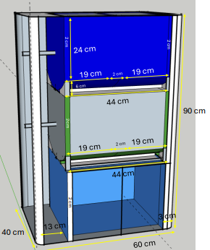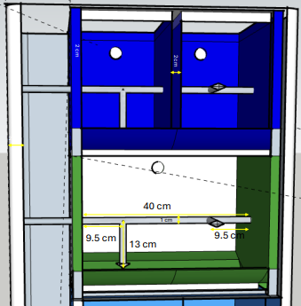
Figure 1.3 New Dimensions of the model

Research, design, and model of pipeline system for Phase 2 integration.
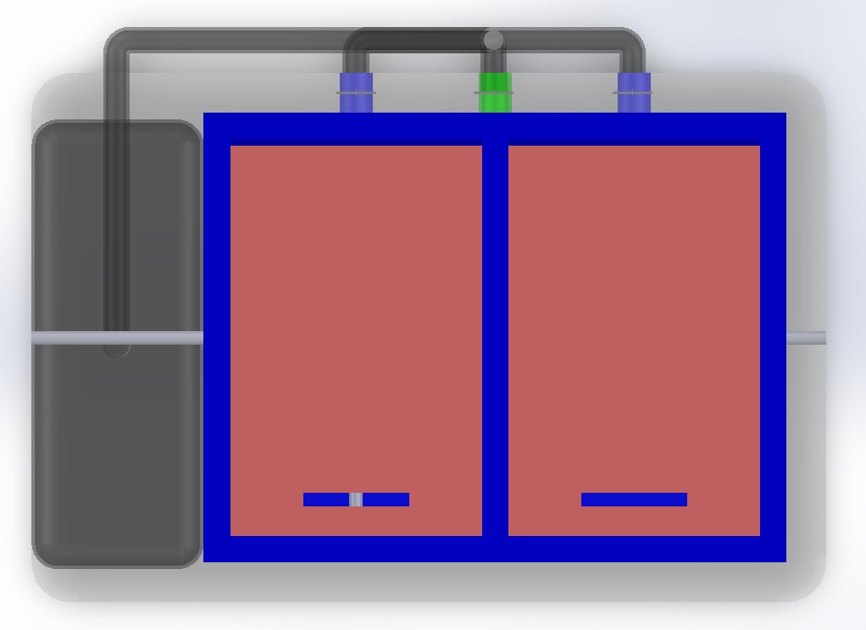
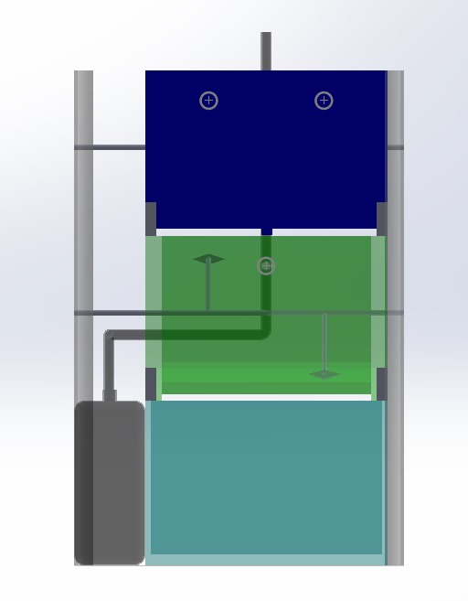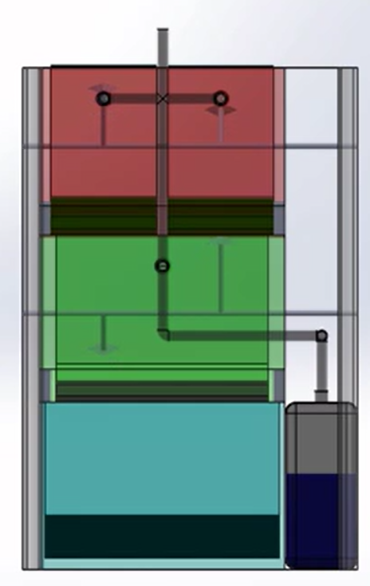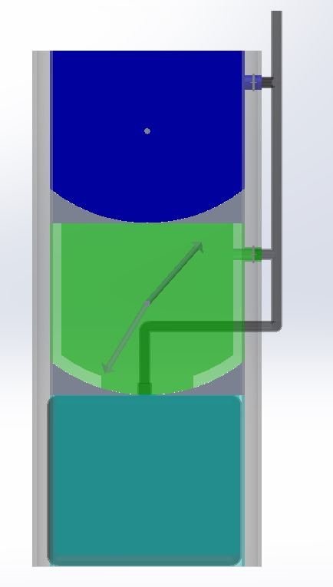
Figure 1.3 & Figure 1.4 The Pipeline integration of the new model
Paddle animations refined and Phase 3 chamber (curing/collection) modelled for composter behaviour.
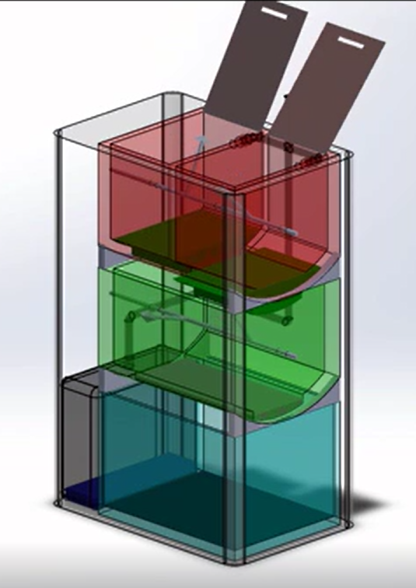
Figure 1.5 Paddle animation of the new model

pipe connection and water tank tested for drainage simulation and moisture separation.

Figure 1.6 & Figure 1.7 Drainage and Moisture separation in the new model
Transparent chamber visuals with colour coded compost stages for clarity.
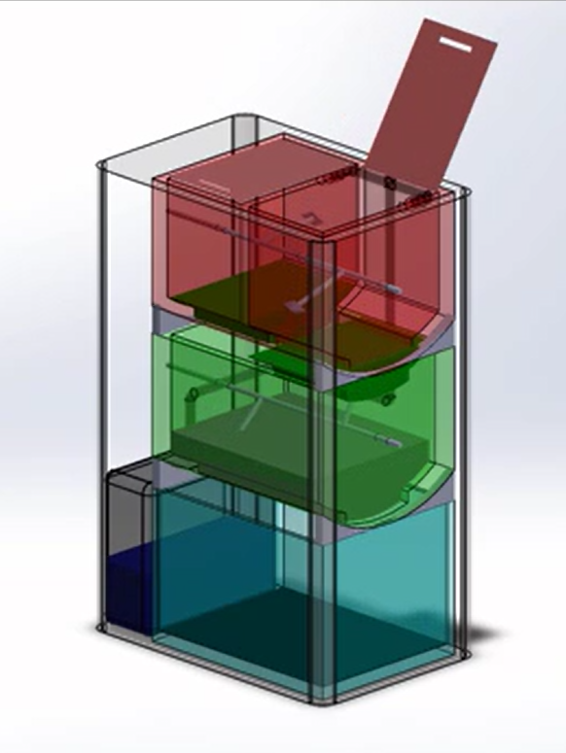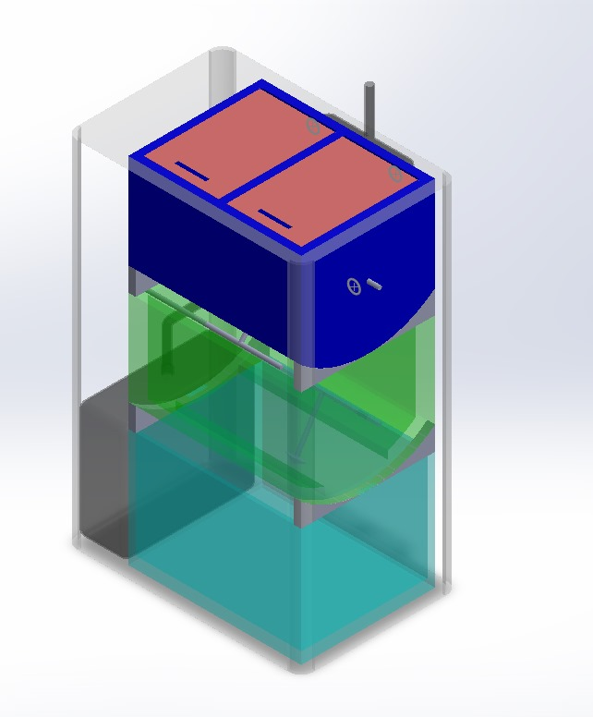
Figure 1.8 Transparent Solidwork model and the Animation Model
Feedback from Client
The client had nice things to say about the team’s clarity in their designs and interest presentation and gave specific tactful suggestions for improvement.
Positive Feedback:
- Attached wall systems were effectively used to articulate internal behaviours of the overall system.
- The paddle animations portrayed realistic counter-rotation.
- The plumbing logic was a stronger improvement more aligned with air flow with moisture separation.
- The compost stages were effectively distinguished with chamber array coding.
Development Suggestions:
- Add mirror pipe systems with “T” joints and cross connections on both sides.
- Add directional arrows for airflow (red) and moisture (blue).
- Animate the compost drawer/bucket on base, for collection.
- Develop the compost texturing with organic looking scraps (banana peels, vegetables scraps).
- Provide an optimised export format (for app) by early September.
Progress Assessment and Reflection
Sprint 1 continued technical refinements, structural accuracy, and visual clarity. The increment was partially deliverable with the pipe system, animations, and color coding demonstrated, while directional arrows, drawer animation, and texture refinements will be continued in Sprint 2.
The team worked around blockers by splitting work based on specialization and preparing backup plans (such as finding pre-built motor/sensor models in external libraries to incorporate at a later date). The review confirmed the project is on schedule, with final refinements and mobile testing in the next sprint.
Challenges and Resolutions
Challenge | Description | Resolution
Mirrored Pipe Connections | The pipe system was only modelled for one side, limiting airflow and condensation. | Will be mirrored on both sides with “T” joints and cross connections in Sprint 5.
Missing Directional Arrows | Animations lacked arrows to show gas and moisture direction. | Arrows will be introduced in red (gas) and blue (moisture) in the next sprint.
Compost Drawer Animation | The base compost drawer was modelled but not yet animated. | Sliding animation will be created for compost collection.
Compost Visual Realism | Compost textures appeared geometric and uniform. | Organic textures and darker shading will be added for maturity representation.
Model Export for App | Current SolidWorks export is not yet optimised for mobile testing. | Lightweight export formats will be prepared for Unity app integration.
This review cycle demonstrated adaptability, problem-solving, and professionalism regarding communication. Although realism in animation and mobile friendliness continues to be an issue, Sprint 4 has established a strong starting point for final tweaks and refinements. Overall, the quality of collaboration and responsiveness to client feedback confirmed great strides were made toward app deployment.

Retrospect (Critical review of the process)
Overview
A retrospective meeting was conducted after Sprint 1 via MS Teams on Friday 22nd of August 2025, from 2:00 PM to 3:30 PM in which they deliberated on how the collaboration workflow was going, and the challenges that arose during the sprint and our plans for the final integration sequence. Our team identified and reflected on progress related to technical steps like animations, visibility in the chambers, and drainage design. They also acknowledged those still to be completed for example, directional arrows and icon, and textures for the compost, and exports app ready. The meeting was framed to prepare the group for the beginning of Sprint 5, for example, placement of the sensors and motors and delivery for mobile.
Meeting Details
Date | Time and Venue | Attendees
22nd August 2025 (Friday) | 2:00 PM – 3:30 PM, Online (MS Teams) | Chrishelle Anthoneyz, Haritha Perera, Thenura Kuruppuarachchi, Senupama Deshapriya
Retrospective
Start Doing | Stop Doing | Keep Doing
Adding directional arrows for airflow and moisture earlier in the animation cycle. | Relying on single model exports without testing smaller intermediate versions. | Weekly check-in calls with structured agendas.
Preparing lightweight export formats for mobile testing during the sprint, not at the end. | Overloading a sprint with too many combined features (e.g., animation + app + textures all at once). | Frequent client reviews and rapid feedback loops.
Applying compost textures and organic visuals (banana peels, vegetable scraps, darker compost) alongside structural modelling. | Delaying validation of pipework and chamber layouts until late in the sprint. | Using Jira consistently to manage task ownership and progress tracking.
Action Items for Upcoming Sprint
- Close the Pipe System Integration:
Placing "T" and cross connections to close the other mirrored pipe systems on each side of the composter, will assist airflow and condensation, to make it more lifelike, and therefore a functioning model.
- Add Directional Arrows into the Animations:
Add directional arrows (red for gas, blue for moisture) right into the animations to show airflow, and condensation behaviour.
- Review the Compost Drawer Animation:
The composter should also have final sliding animation for the bottom compost collection drawer to complete the composting cycle.
- Improve the Composting Visuals:
Change the placeholder compost contents, to have organic textures (ie banana peel, apple cores, vegetable scraps).
- Optimize the exported Model for the Mobile App:
There will be early testing at each sprint so we can confirm if there are any issues with integrating all the components.
- Mobile App Integration (Sprint 2):
Start to add the composter model into the mobile app environment. All keep it all simple, and accessible UI.
- Where to Put Sensors and Motors (Sprint 2):
Find or create prebuilt motor models and sensor models to integrate into the 3D composter. Put the gas sensor, temperature sensor, and moisture sensor where they would actually be in the chamber.
- Hardware Team Collaboration:
For the virtual design to reflect the physical design created by the hardware group, we need to closely verify that the motors and sensors, the design of the drainage system, and actuator fit with how we plan to integrate the app.
- App-Side Testing / Validation:
Start app-side testing, using mock sensor data to mock the actual sensors and simply pairing the QR code with some made-up model to check that the app can connect to it.

Lessons learned (Critical review of SPRINT one experience and future plan)
1. The Value of Early Testing Text and Visuals
From this sprint, we now see how adding animations without arrows added uncertainty in the logic of air movement and condensation. Waiting until the end of the sprint to add arrows led to updating these animations and made future revisions burdensome. Learning we can test visually in the first half of a sprint early avoids that uncertainty and miscommunication with our client.
2. Exporting Needs to Have Iteration
The model exports still carried a lot of weight, resulting in already long preparation times on mobile. We learned the importance of exporting demos of lighter weights during the sprint rather than leaving that work until the end of the (12 week) sprint. In doing so, we created smoother flows when testing for mobile use, even avoiding potential sticking points all together.
3. The Importance of Realism
The client feedback on textures of compost is a good example of how even fake-looking blocks contributed to a sense of realism. Using organic imagery is a good practice regarding educational value and client satisfaction in terms of presentation and realism.
4. Prioritizing Workloads
Even acknowledging the complexity of a lot of simultaneous development; we found adding too many simultaneous improvements (pipes, textures, exports, animations) added weight at mid-sprint. We learned we should always prioritize required deliverables first (there's multiple deliverables for pipe logic and have it work with export testing) and placing improvements we cannot address (at present) in a future sprint.
5. Technical Realignment of Hardware Needs Attention
We learned there are many questions to ensure hardware and electronics are positioned for real alignment. Our learning would suggest both hardware and software development should happen in parallel so elements do not get misaligned (for example dropping motors or sensors below the surface).

Practical and Feasible Future Suggestions
Area | Recommendation | How it will be implemented
Animation Logic | Add directional arrows for airflow and condensation earlier. | Test airflow and moisture animations mid-sprint instead of waiting for the demo.
Export Process | Prepare lightweight mobile exports iteratively. | Export weekly in GLB format and test performance on Unity preview.
Visual Realism | Replace placeholder compost with organic textures. | Introduce banana peels, scraps, and shading to differentiate compost maturity.
Workload Management | Prioritise critical deliverables before extras. | Use Jira sprint boards to flag "must complete" vs "optional" tasks.
Hardware Integration | Align motor/sensor placement with digital model. | Coordinate with the hardware team and label positions in the 3D model.

Plans for Next Sprint
• Finalise pipe system including mirrored connections and cross-links.
• Add directional arrows onto all airflow and moisture animations.
• Implement compost drawer animation.
• Use organic compost visuals for realism.
• Optimise and test lightweight exports to ensure mobile app integration.
• Begin mobile app integration with a 3D model import and basic controls.
• Add and label sensor and motor placements for future data connectivity.
• Better collaboration with the hardware team to remain in sync.

